SELinux Basics Theory (1 hour): Introduction to SELinux and its role in server security. Understanding SELinux modes and contexts. Practical (1 hour): Enable SELinux and troubleshoot access denials. Task: Document an SELinux configuration with resolved issues.

Tasks

1. Check the current SELinux status on your Linux server using the getenforce and sestatus commands, and write down which mode (Enforcing, Permissive, or Disabled) is currently active.

ANS:

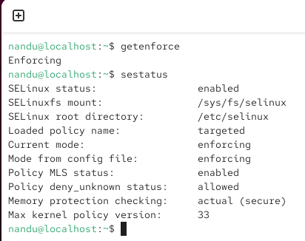

- getenforce → Enforcing
- SELinux status → enabled
- Current mode → enforcing
- Mode from config file → enforcing

2. Switch SELinux to Enforcing mode using setenforce and verify the change with getenforce. You may need sudo privileges to change the mode.

ANS:

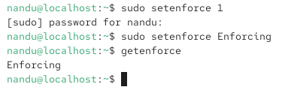

3. Simulate an SELinux access denial by creating a new directory (e.g., /tmp/testapp), setting its context to a type not allowed for your web server (such as user_home_t), and then try to serve a file from it using your web server. Note the error message in /var/log/audit/audit.log or /var/log/messages.

ANS:

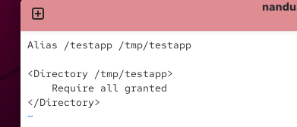

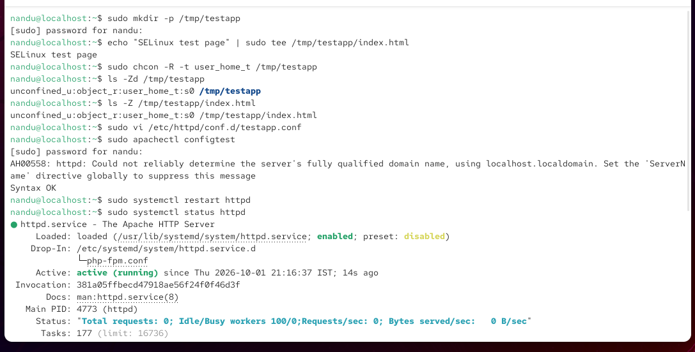

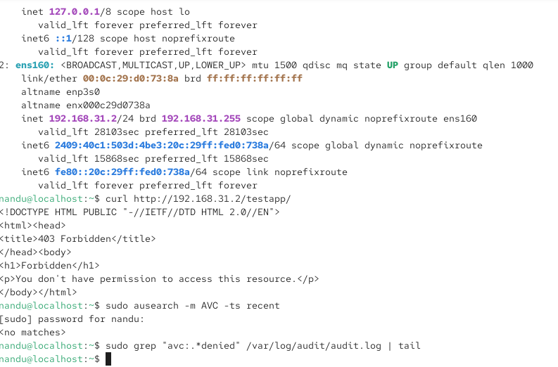

4. Use the chcon command to assign the correct SELinux context (e.g., httpd_sys_content_t) to your test directory or file so your web server can access it, then confirm the issue is resolved by reloading the page successfully.

ANS:

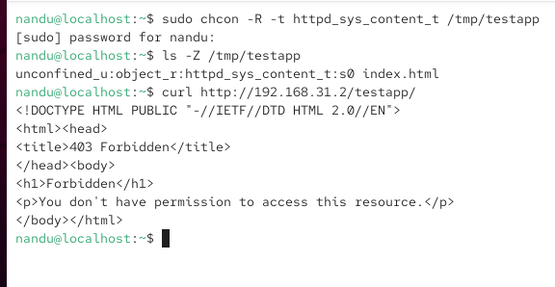

5. Document the steps you took to identify and resolve the SELinux access denial, including the commands used, the error log entry, and a brief explanation of how SELinux contexts control access.

ANS:

